**Grade Needed**

**Directions**

Write a program that given a student's three six weeks averages will calculate the grade the student needs to make on his/her semester exam to earn the desired semester average.

For example, Zack wants to earn at least a 90 for the semester. If his three six weeks averages are 92, 86, and 88 he would need to make at least a 95 on his semester exam to achieve his goal.

The table below shows other examples.

|  |  |  |
| --- | --- | --- |
| **Goal** | **Six Weeks Avgs** | **Grade Needed** |
| 80 | 86,78,62 | 98.7 |
| 70 | 75,65,60 | 83.3 |
| 90 | 99,100,99 | 52.7 |

Here is the formula for calculating the grade needed on the semester exam:

gradeNeeded = (semesterAvgGoal - (0.8 * (sixWeeks1 + sixWeeks2 + sixWeeks3) / 3)) / 0.2

Problem Decomposition

Decompose the problem using the following structure chart.

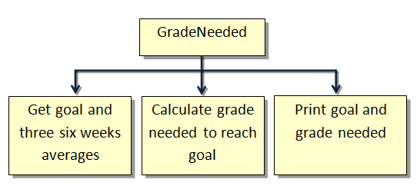

Stub Program

Start by creating a stub program that includes the following three methods: **getData**, **calculateGradeNeeded**, and**printResults**. Include println statements within each method that print the name of the method when it is executed. Refer to sample run below.

**Source File**

GradeNeeded.java

**Sample Run**

-----------------

getData

-----------------

Enter desired semester average -->90

Enter 1st six weeks average -->92

Enter 2nd six weeks average -->86

Enter 3rd six weeks average -->88

----------------------

calculateGradeNeeded

----------------------

-----------------

printResults

-----------------

Semester Average Goal = 90

Grade Needed to Achieve Goal = 95.33333333333331